Title: CMPE 202-Personal Project UML Parser

Name: Faisal Mohammad

Student id:010700300

Steps to import the UML parser in your eclipse:

1. Download the project zip file Extract the Zip the content of zip file are:
   1. Project Zip (UMLParser.zip)
   2. Readme
   3. Compile Instructions
   4. Test cases
   5. Jars (jars to be included)
2. Import the UMLParser.zip into eclipse using the File>Import option.

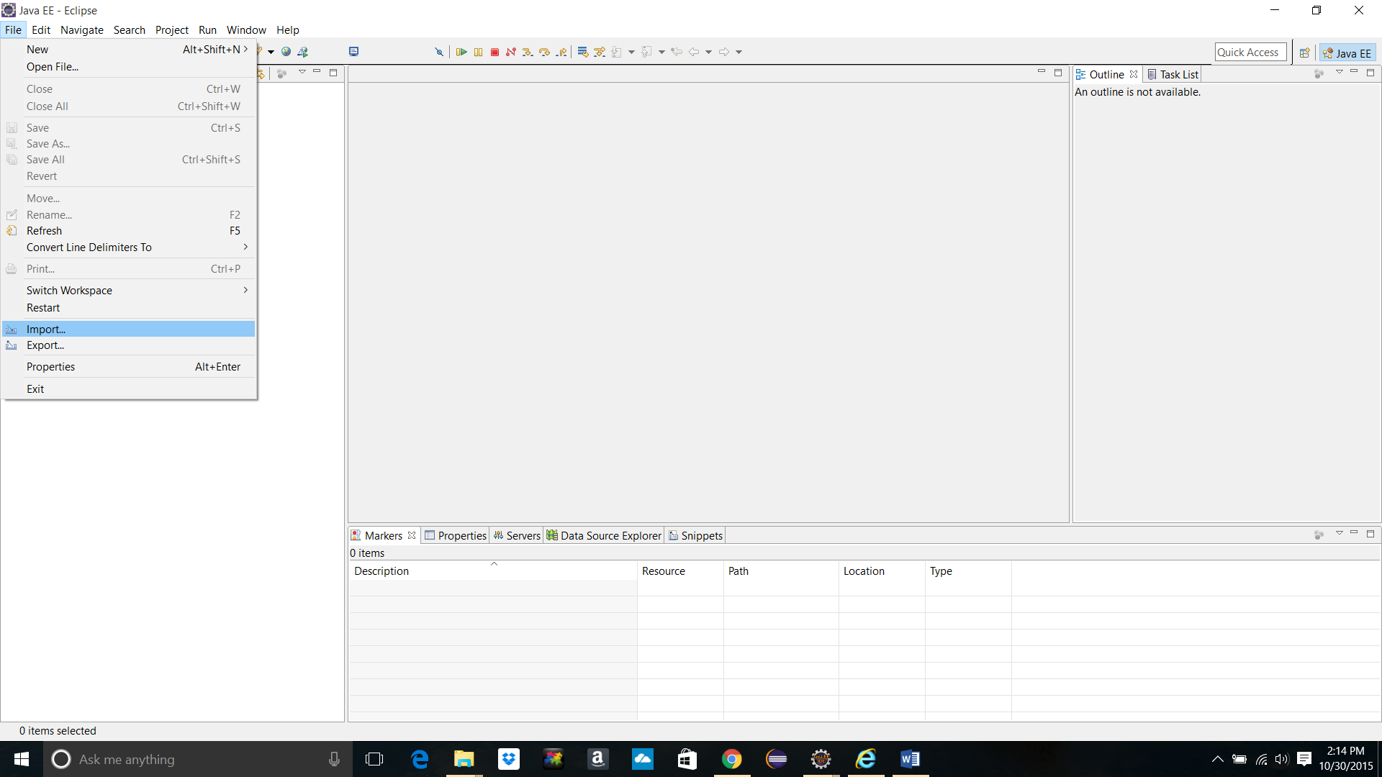

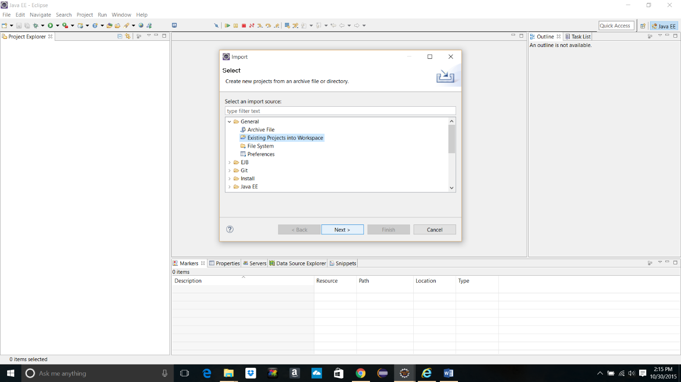

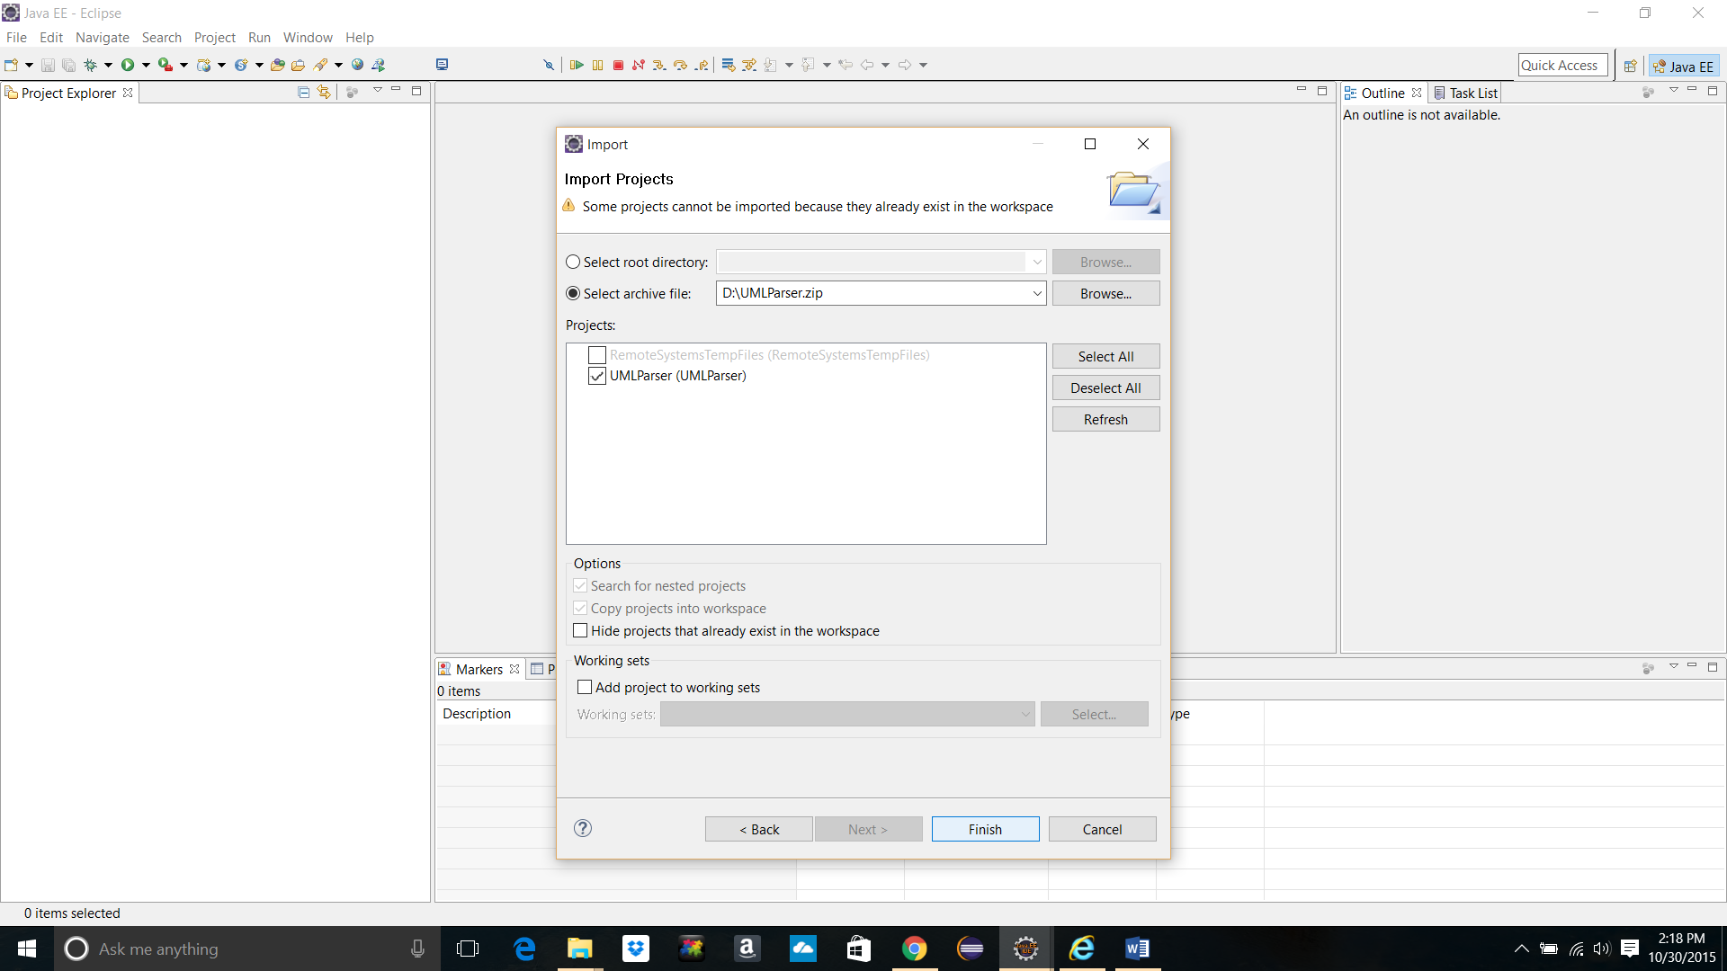



1. Add the following jar files to your java project (Available in “Jars” folder):
   1. javaparser.jar
   2. plantuml.jar

Right Click on Project Name > Build Path > Configure Build Path > Libraries > Add External Jars

1. Download and install graphviz

<http://www.graphviz.org/pub/graphviz/stable/windows/graphviz-2.38.msi>

1. To run the project add Input path as the first argument and output path as the second argument to the argument list.

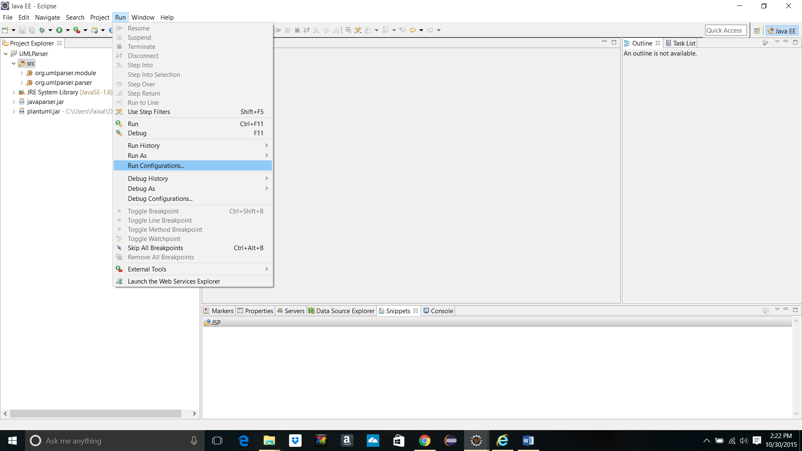

1. Run the project.

